**Name: Session:**

**Programming II**

**Lab Exercise 3.11.2024**

1. Create an application that prompts the user to enter today’s sales for five stores. The program should then display a simple bar graph comparing the stores sales. Create each bar in the graph by displaying a row of asterisks (*) in a list box. Each asterisk in a bar represents $100 in sales.

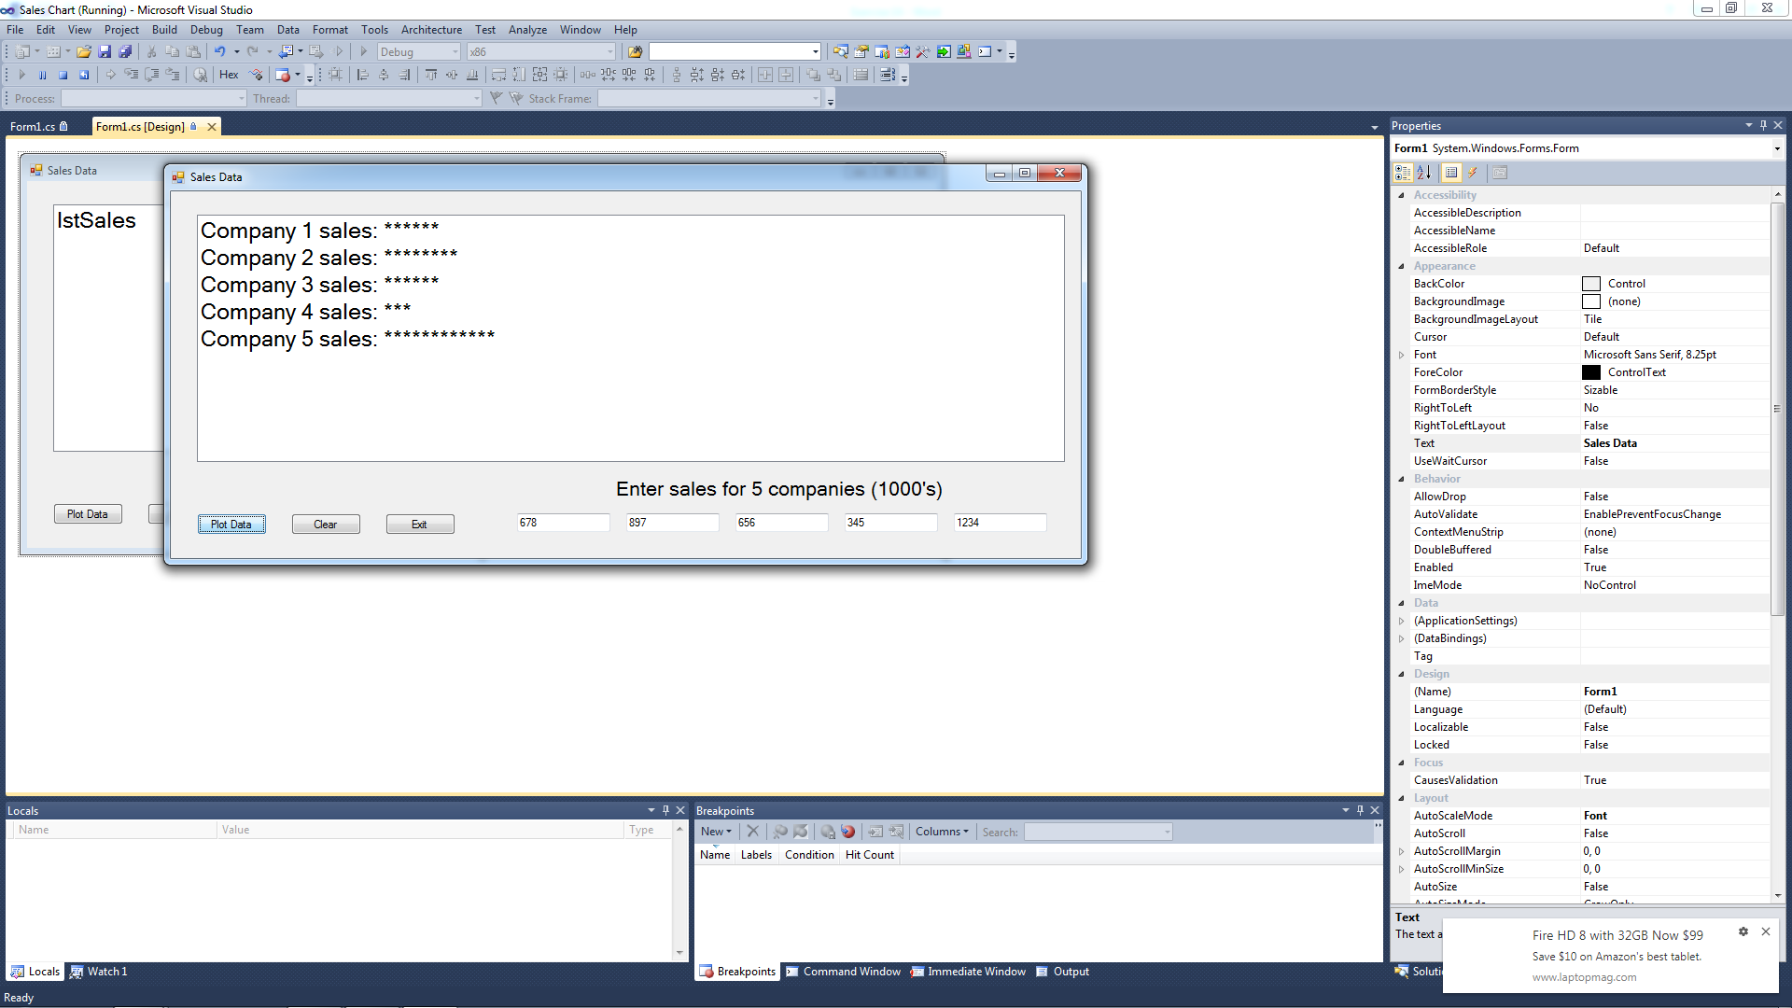

1. Create an application that will predict the approximate size of the population of organisms. The user should select or enter a starting number of organisms in a combo box, enter the average daily population increase (as a percentage) in a text box, and select or enter the number of days the organisms will be left to multiply in another combo box. For example, if the user enters the following values:

Starting number of organisms (in millions): 2

Average daily increase: 30%

Number of days to multiply: 10

The application should display the following table of data.

|  |  |
| --- | --- |
| **Day** | **Approximate Population (in millions)** |
| 1 | 2 |
| 2 | 2.6 |
| 3 | 3.38 |
| 4 | 4.393 |
| 5 | 5.7122 |
| 6 | 7.42586 |
| 7 | 9.653619 |
| 8 | 12.5497 |
| 9 | 16.31462 |
| 10 | 21.209 |

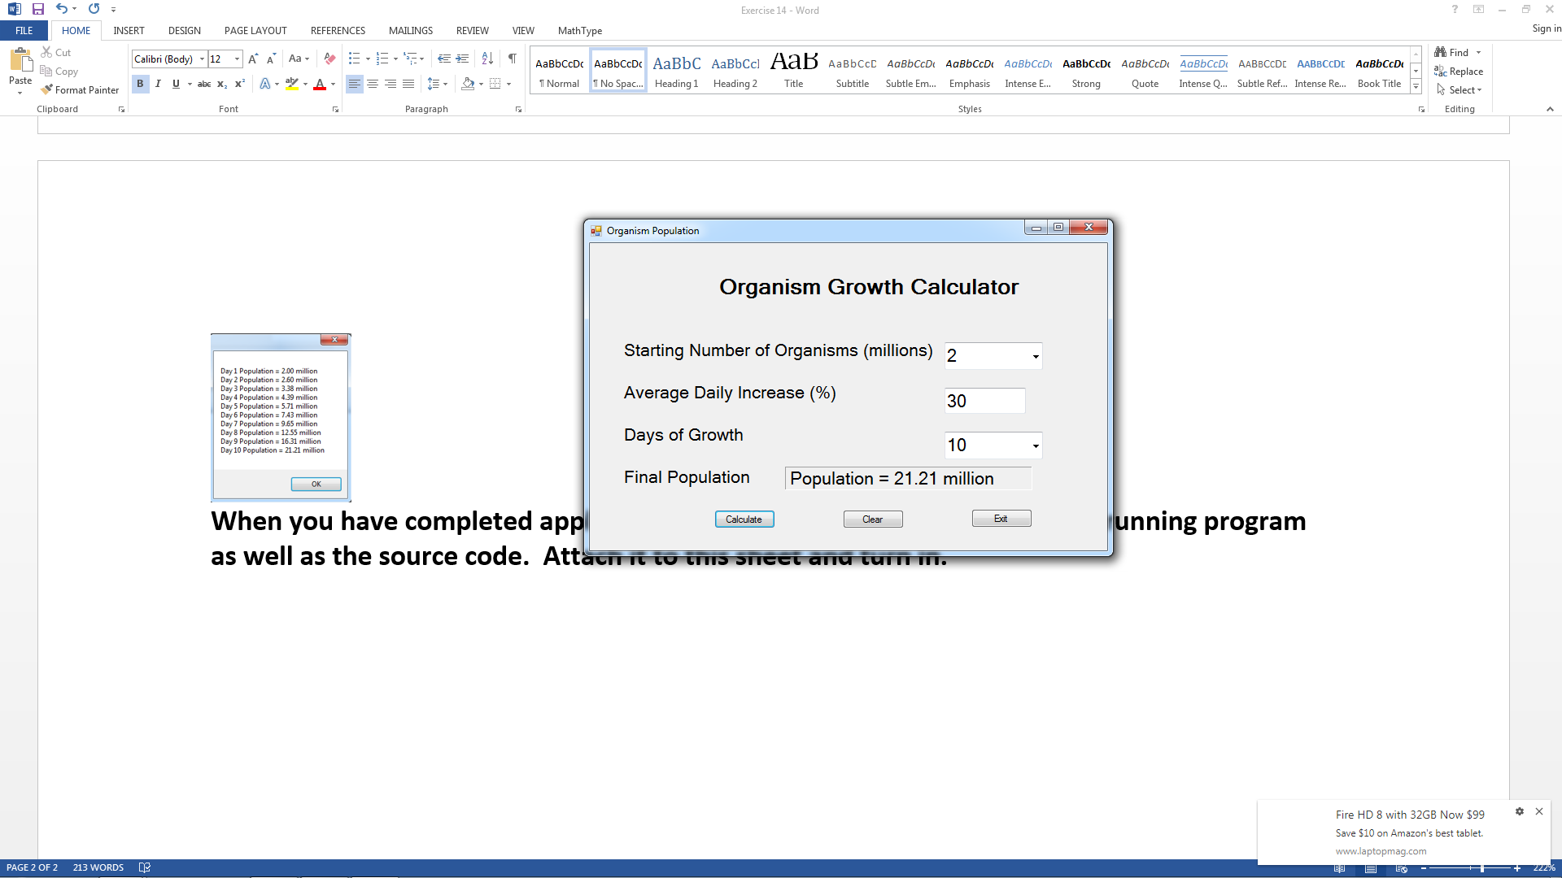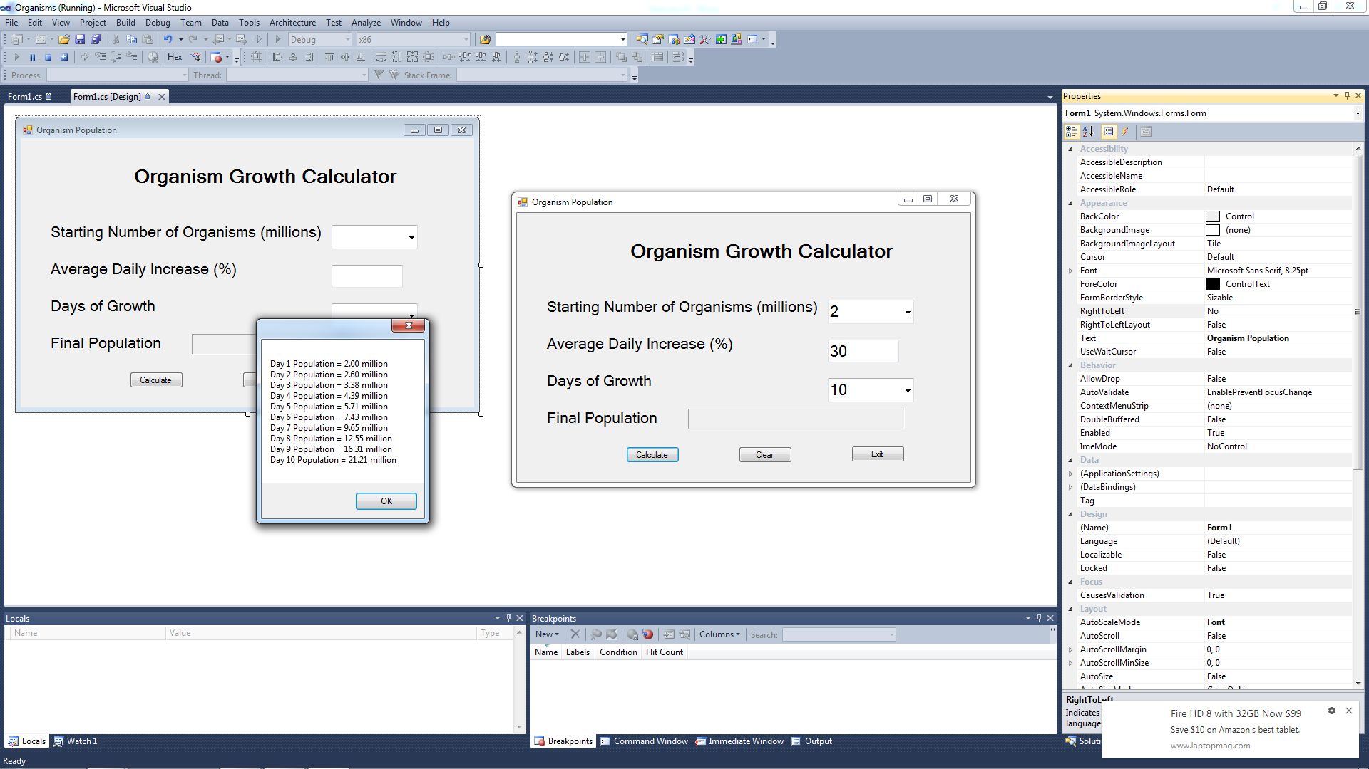

**When you have completed application 1 and 2, submit a screen shot of your running program as well as the source code.**